

**Minecraft and the Minecraft Logo are owned by Mojang. This game nor logo is owned or created by my in any way. No copyright infringement intended.**

**Minecraft Tutorials**

**#1 Buying the game**

**Please note: If you have already got a Minecraft account and have already bought the game, please skip this tutorial. You also require internet.**

INTRODUCTION

This tutorial series will teach you the basics of the very successful (and addicting) game. Follow the simple steps and get playing in no time!

THE MINECRAFT WEBSITE

First of, make sure you have access to the internet (internetwork). If you do not, then you can not continue. First you need to go to the Minecraft website. It is a network website (.net). First we need to open up an internet browser. I personally recommend Google Chrome or Mozilla Firefox. Other web browsers include:

MICROSOFT INTERNET EXPLORER.

GOOGLE CHROME

MOZILLA FIREFOX

MICROSOFT EDGE (AS OF JULY 29th 2015, WINDOWS 10)

Links for the web browsers:

MICROSOFT INTERNET EXPLORER – <http://windows.microsoft.com/en-GB/internet-explorer/download-ie>

GOOGLE CHROME – <http://www.google.com/chrome/>

MOZILLA FIREFOX – <https://www.mozilla.org/en-GB/firefox/new/>

MICROSOFT EDGE – AS OF THIS VERSION OF THE DOCUMENT – THERE IS NO AVALIBLE DOWNLOAD.

Every OS has a web browser coming with it. If you do not like your current web browser, then use that one to download a better one.

One you have your preferred web browser open, go to the address: <http://minecraft.net/> or search it in a search engine. Once there, simply follow the steps below.

CREATING THE ACCOUNT

You should see this:

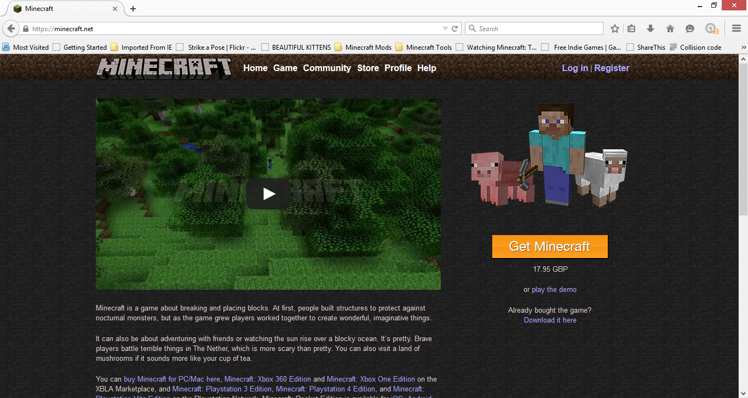

Once taking a look around, get back to the homepage and click the button “Register” which can be found in the top bar.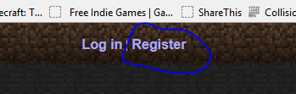

Fill in the information. If you need to, get an adult to help you!

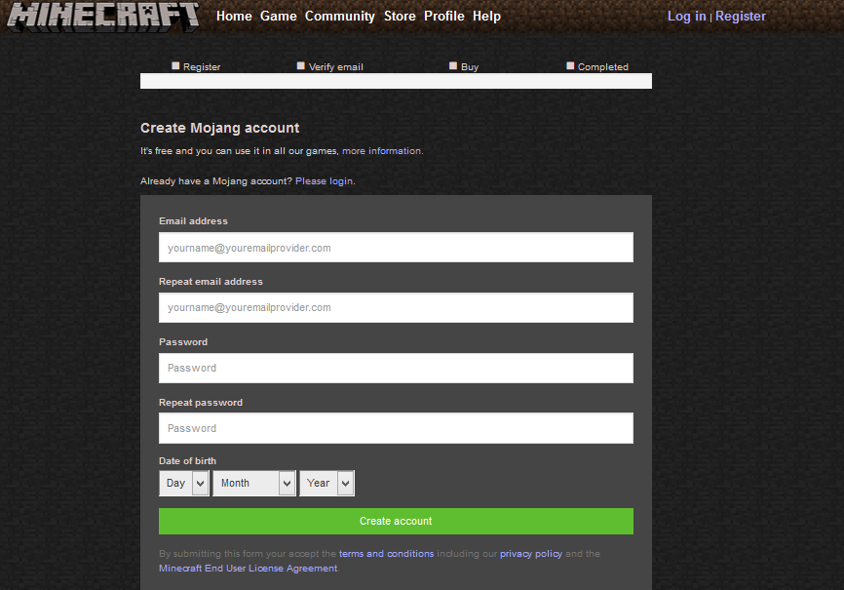

And remember to read the agreements! If you do something that is against them, your account may be deleted!



The final step of the creating of the account is to confirm your email. An email will be sent to the email you included when creating the account. Go to the email, and follow the instructions included in the email. You have now created your account. You may also be asked to set up a security question that you will be asked to answer when you log out and log back in again. You can set up up to 3 of them.

Now to buy the game. Enter all the information and follow the steps provided. Ask an adult help if you need some. Now just continue the following steps!

LOGGING IN

To log in, simply click on “Log In” which can be found in the top bar of the website. This will take you to the log in page. Type in the required information. Answer the security question if needed and click log in.

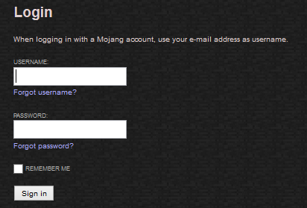

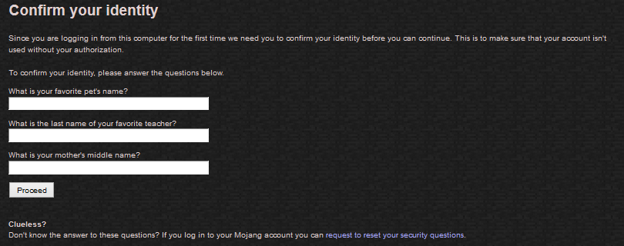

You will now be logged in.



DOWNLOADING THE GAME

Once logged in, you need to download the minecraft launcher. To do this click on the download button.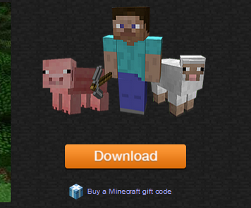

Now you should see this: 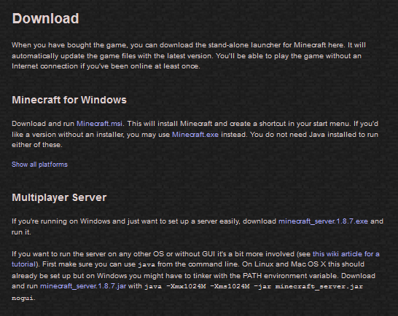

Now download minecraft.msi if you have windows. If you do not have the windows operating system, click show all platforms and download the option for your operating system.

INSTALLING THE MINECRAFT LAUNCHER

Please